27/10/2023
Let’s focus only on these pending work/modules/bugs:
- For app:
  - Revert Process Payroll (see our comments in your spreadsheet)
>> Pending works are noted.
  - Payroll Page Employee profile – (everything in this module).
  - Loan/ Advance Pay Request - In the App - you have to change the word "Advance" to "Loan". In the Request, the "Date of Requirement" field is missing... please check and correct all this. In the Employee App, also a Tab is missing to view all requests and their statuses. Eg, If HR Declines a request with a reason, it should show to the employee, so he/she can re-apply or make new request, etc…
>> Yesterday, during the meeting, you mentioned that this module would be functional in Phase 2.
WE CAN ONLY KEEP “LOAN REQUEST”, AND REMOVE “ADVANCE PAY” FOR NOW (WE CAN DO THAT IN PHASE 2). BUT SOME WORK IS STILL LEFT FOR THIS AS MENTIONED IN C. ABOVE.
  - Employees Profile - Projects Module
>>Incorporating an entire module into an HR or profile profile requires a considerable amount of time and effort.
OKAY – Then how to handle this part so it does not show to all employees?
  - Notifications & Emails - Employer (Push notifications & Emails)
>>Please specify which functions require notifications and emails. Currently, attendance and overtime approval and decline notifications are in place.
WE HAVE ALREADY PROVIDED COMPLETE DETAILS FOR THIS EARLIER – ROBIN CHECK!
  - Notifications & Emails – Employee
>>Please specify which functions require notifications and emails. Currently, attendance and overtime approval and decline notifications are in place.
WE HAVE ALREADY PROVIDED COMPLETE DETAILS FOR THIS EARLIER – ROBIN CHECK!
  - Uploads Module in HR section
>> Pending works are noted.

  - My Files module in Employee section
>> Pending works are noted.
  - Payslip Employee - Can't Process Payroll. Need API Update. Download existing Payslip - After Selecting the year, month, pay date, that Payslip should display in the page. Downloaded payslip file names should include payslip date and understandable. Sharing Issue any pdf file as payslip.
>> During yesterday's meeting, you emphasized that these are the most crucial areas of work. As a result, we dedicated our efforts to this section, working diligently to complete it.
- For Web - pending
  - Payroll Template – Bank templates
  - Payment Gateway
  - Import Existing employee clubbed with historical data and statutory leaves
  - Payroll Template (Include: Mpaisa and MyCash Wallet Templates—this is missing in your document – for split payment need these 2 also)
  - Pay Roll - API
  - FRCS Report page
  - Download FRCS report
  - Payroll - while payroll processing, update the required FRCS fields.
  - Revert Payroll - Note: Only those processes that have been processed should revert. In case of disconnecting from internet/server/ failures etc., some may not get processed so need not to be reverted.
  - Back Up (discuss )
  - Deduction & Loan/ Advance Request
PLEASE REFER TO OUR DOCUMENT, “Deduction & Loan/Advance Request – Workflow” for the the Deduction functionality and design.
  - Notifications & Emails - Super Admin
  - Missing Report: Provident Fund report - “Monthly Contribution”.
@Robin: We had discussed this very long ago. Discuss again if you not sure. We shall share the Sample CSV Template.

Errors found:
- Error found when clicking Edit attendance of some employees. Also in the “Edit employees” Attendance tab, to include Extra hours worked like how it is when Creating attendance (missing).
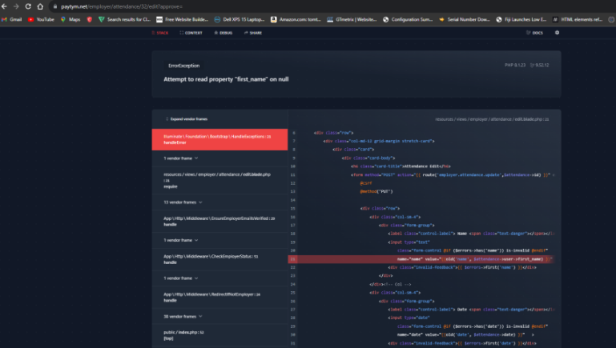
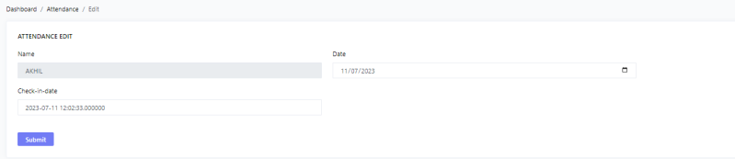
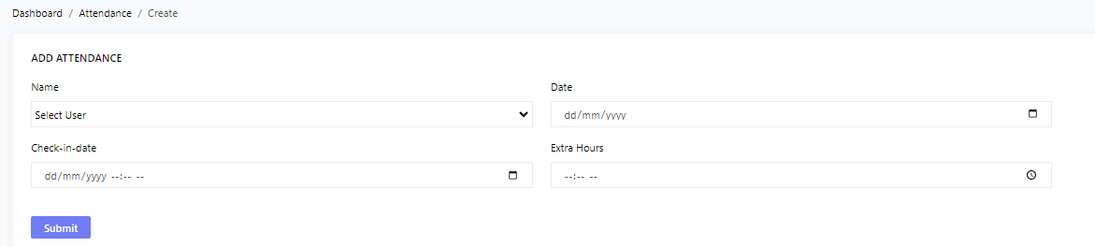

- Payroll Generate still giving the same errors both in app and web.

Changes to be made:
- Add “Extra Hours at Overtime Rate*” to input for hours to be worked on overtime rate. After these hours are passed any hours recorded will be at double time rate.
Dashboard / Payroll Settings
HOURLY SETTINGS
Over time rate* Double time rate*

Extra Hours at Overtime Rate*


- In the “Attendance” tab in the “Reports” tab, add new column stating the Extra Hours recorded after the normal time for the Hourly rated employees.
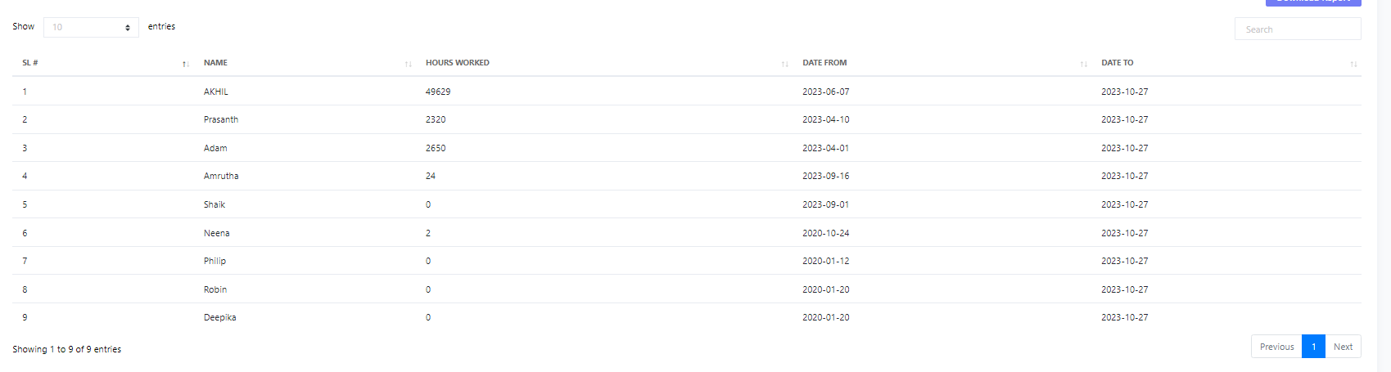

(NEW):
- In the Employer Registration Form, add upload file for Tax Identification Number (TIN) Letter.
